Brenner Gradient Topology-Based Autofocusing Framework for Fourier Ptychography Microscopy
¹Gaurang Garg,^{2,#}Pradipta Mukherjee
¹Indian Institute of Technology, Delhi
#pmukherjee@cbme.iitd.ac.in
Accurate defocus estimation in Fourier Ptychographic Microscopy (FPM) remains challenging for transparent samples, where amplitude-contrast autofocus metrics fail. We introduce an object-aware framework that analyses the topology of Brenner gradient curve to decouple wave propagation from digital artifacts, enabling automatic sample classification and optimal focus selection for universal, label-free FPM reconstruction.
Fourier Ptychographic Microscopy (FPM) is a powerful computational imaging technique, but its high-fidelity phase retrieval relies entirely on accurate initial defocus estimation. In label-free biomedical applications, samples are typically transparent. Traditional autofocusing metrics, which maximize the Brenner gradient to find amplitude contrast peaks, fail catastrophically on these phase objects due to complex wave-matter interactions.
This work establishes that applying standard contrast maximization algorithms to transparent samples ignores critical optical physics. We identified three non-linear topological phenomena on the Brenner curve that cause conventional algorithms to fail: Phase Inversion, where the true focal plane manifests as a global minimum rather than a peak; Amplitude-Phase Crosstalk in complex tissues, which heavily skews the contrast curve and breaks symmetrical search rules; and the Gibbs Anomaly, where finite numerical aperture (NA) clipping forces invisible diffraction boundaries to form deceptive, W-shaped false peaks.
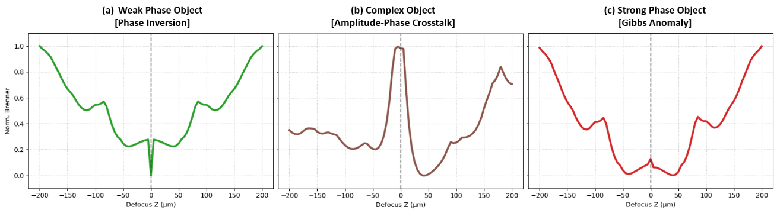
Figure 1 Brenner curve for different objects
To overcome these optical limitations, we propose a novel, object-aware autofocusing framework that mathematically decouples macroscopic wave propagation from microscopic digital ringing artifacts. Following a rapid simulated Z-sweep, our multi-scale topological profiler functions as an autonomous logic gate. By extracting specific geometric parameters from the gradient curve; namely Macro-Curvature to capture broad Transport of Intensity Equation physics, Micro-Curvature to detect sharp clipping artifacts, and a Brenner Asymmetry Index, the system successfully classifies the specimen's physical nature without prior knowledge.
Based on these parameters, the framework deterministically routes the optical data to the correct mathematical solution. It locks onto maximums for pure amplitude, minimums for weak phase, and immediately triggers a multi-LED universal fallback loop if Gibbs anomalies or heavy skews are detected. Ultimately, this approach eliminates local minima traps, providing a universal, highly accurate computational pre-step for robust, label-free FPM reconstructions.
References:
[1] G. Zheng, R. Horstmeyer, and C. Yang, Nature Photonics 7, 739–745 (2013).
[2] F. Dubois, C. Schockaert, N. Callens, and C. Yourassowsky, Opt. Express, 14, 5895–5908 (2006)
[3] S. Schoell, F. Mualla, B. Sommerfeldt, S. Steidl, A. Maier, R. Buchholz, and J. Hornegger, Journal of Microscopy 254, 65–74 (2014).
[4] S. Yazdanfar, K. B. Kenny, K. Tasimi, A. D. Corwin, E. L. Dixon, and R. J. Filkins, Opt. Express, 16, 8670–8677 (2008).

